**Unit 1: Government and Economics**

.

1. **What are the ways citizens participate in their country?**
2. **What factors influence an economy?**
3. **What are trade barriers and what are three examples?**

**SS7CG1, SS7CG4, SS7E1**

**1****732**

**What will I need to complete for this unit?**

**Assignment** **Due Date**

1. Government Flow Chart
2. Notebook Check
3. Formal Assessment

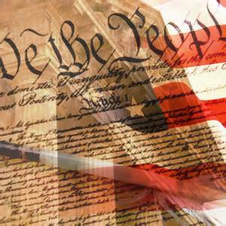

**Vocabulary**

1. Dictatorship 1. Market Economy
2. Presidential Democracy 2. Mixed Economy
3. Parliamentary Democracy 3. Traditional Economy
4. Cabinet 4. Command Economy
5. Monarchy 5. Human Capital
6. Autocracy 6. Capital
7. Government 7. Entrepreneur
8. Oligarchy 8. Tariff
9. Constitution 9. Quota
10. Theocracy 10 .Embargo
11. Republic 11. Foreign Exchange

|  |  |
| --- | --- |
| Government |  |
| Constitution |  |
| Cabinet |  |
| Parliamentary Democracy |  |
| Presidential Democracy |  |
| Autocracy |  |
| Monarchy |  |
| Dictatorship |  |
| Oligarchy |  |
| Theocracy |  |
| Communism |  |
| Market Economy |  |
| Mixed Economy |  |
| Traditional Economy |  |
| Command Economy |  |
| Capital |  |
| Human Capital |  |
| Entrepreneur |  |
| Tariff |  |
| Quota |  |
| Embargo |  |