**MAP SKILLS**

**1****732**

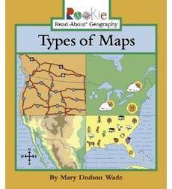

Essential Questions

1. **How do we use maps to find information?**

**ANSWER:**

GPS Standards

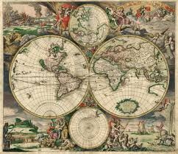

**Social Studies Skills Matrices:**

**Map and Globe Skills 1-12**

**Vocabulary**

1. Latitude 12. Political Map
2. Longitude 13. Physical Map
3. Symbols 14. Thematic Map
4. Scale 15. Projection Map
5. Compass Rose 16. Qualitative Map
6. Legend 17. Absolute Location
7. Prime Meridian 18. Relative Location
8. Equator
9. Map Grid
10. International Dateline
11. Hemisphere

|  |  |
| --- | --- |
| Latitude |  |
| Longitude |  |
| Symbols |  |
| Scale |  |
| Compass Rose |  |
| Legend |  |
| Prime Meridian |  |
| Equator |  |
| Map Grid |  |
| International Dateline |  |
| Hemisphere |  |
| Political Map |  |
| Physical Map |  |
| Thematic Map |  |
| Projection Map |  |
| Qualitative Map |  |
| Absolute Location |  |
| Relative Location |  |